**R Code for Examples in the book**

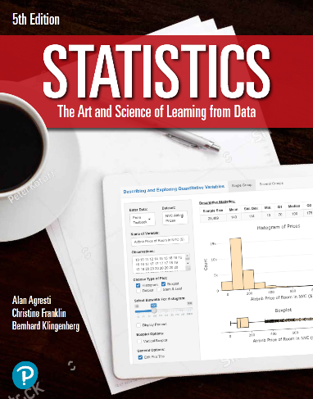

***“Statistics: The Art and Science of Learning from Data”***

**by Agresti, Franklin and Klingenberg, 5th edition**

**Chapter 10**

**Example 3: Standard Error for the Difference of Two Sample Proportions**

## Reading in data for the first proportion

x1 <- 347  
n1 <- 11535  
phat1 <- x1 / n1

## Reading in data for the second proportion

x2 <- 327  
n2 <- 14035  
phat2 <- x2 / n2

## To compute the mean of the difference

mean <- phat1 - phat2  
mean

## [1] 0.006783462

## To compute the standard error of the difference

se <- sqrt((phat1 * (1 - phat1) / n1) + (phat2 * (1 - phat2) / n2))  
se

## [1] 0.002037363